Lab 0 - Create your Elastic Cloud Environment

***Estimated Time for This Lab: 20 Min***

1. Sign up for the Elastic Cloud Trial

Visit <https://cloud.elastic.co> and click “Sign up now”

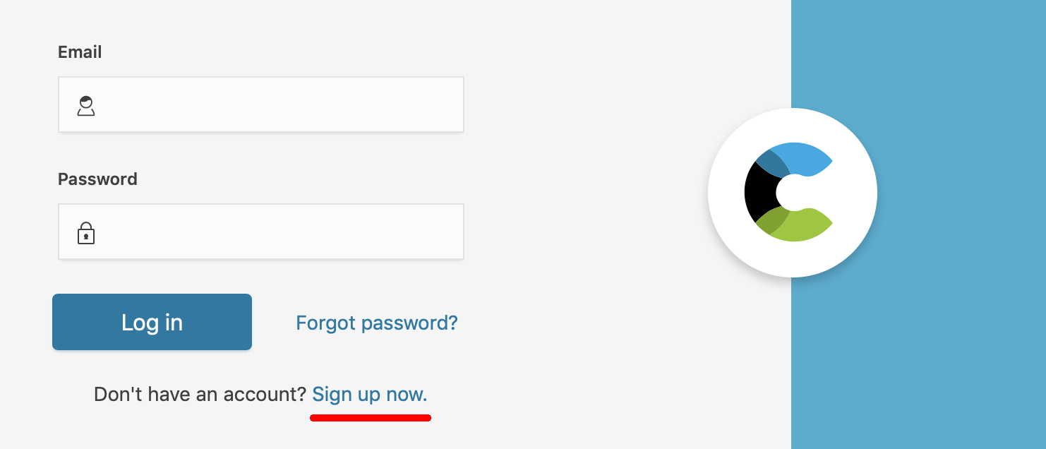

2. Enter your business email (no credit card is required).

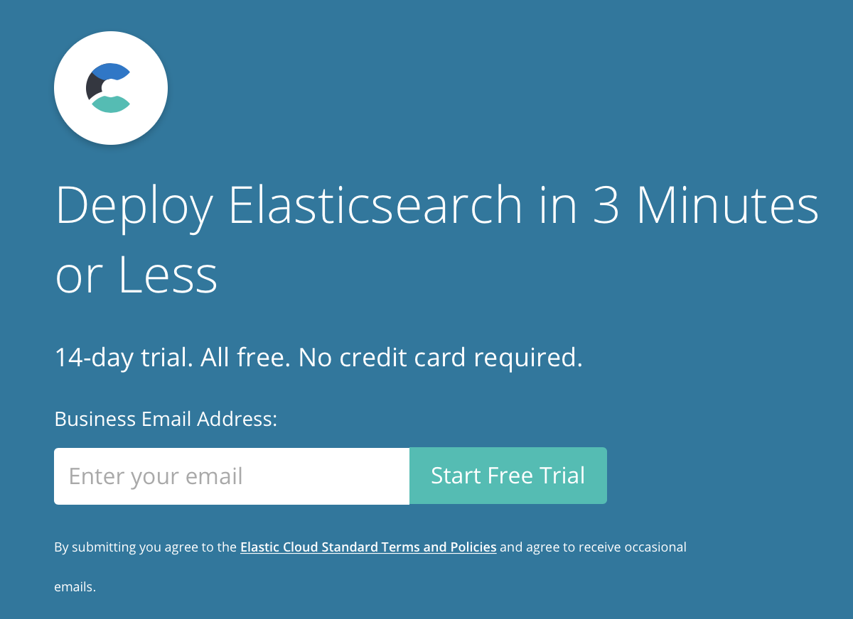

3. Check your email to verify your account.

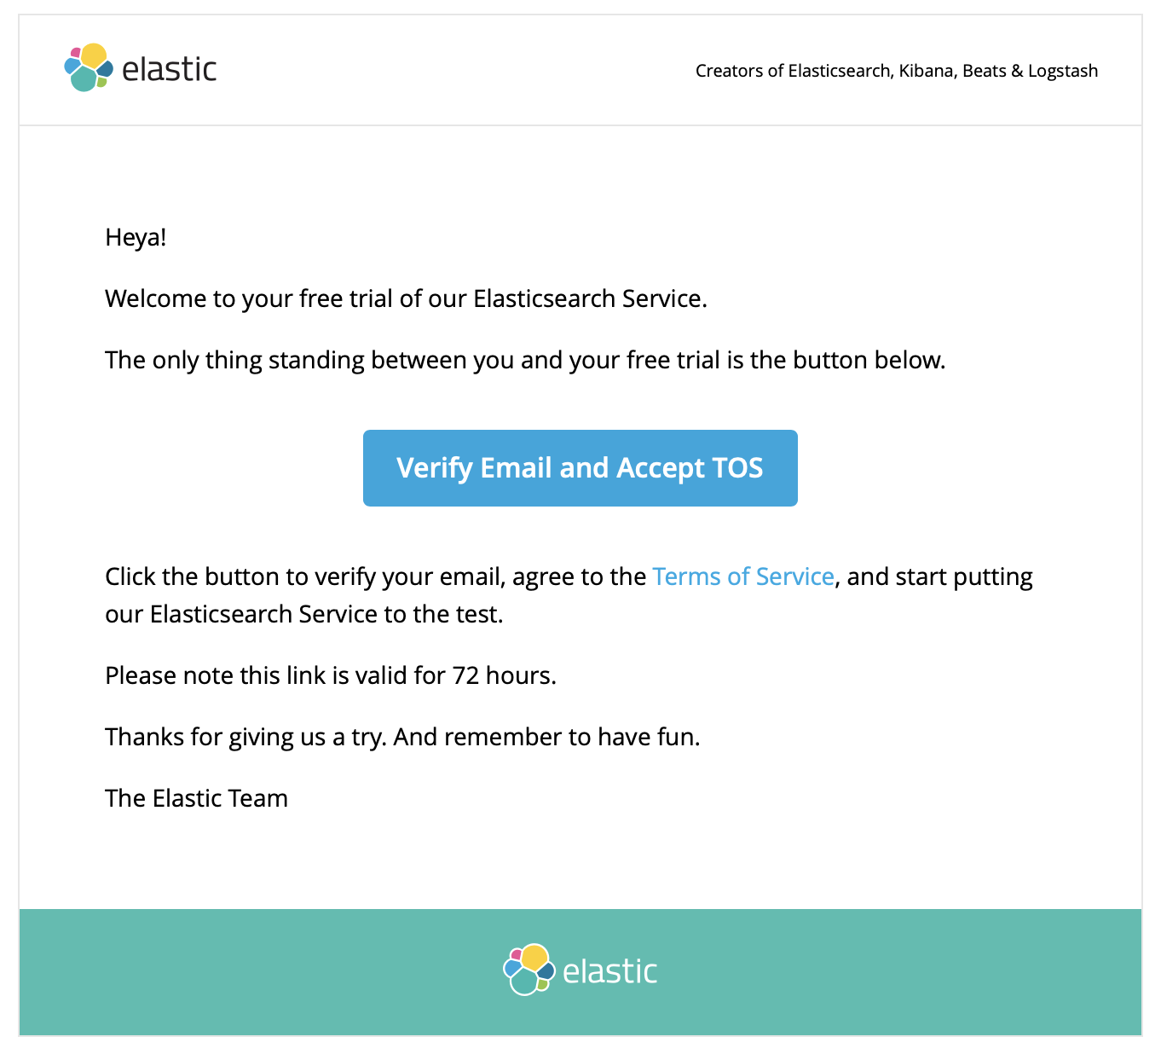

4. Log in and create give your account a strong password.

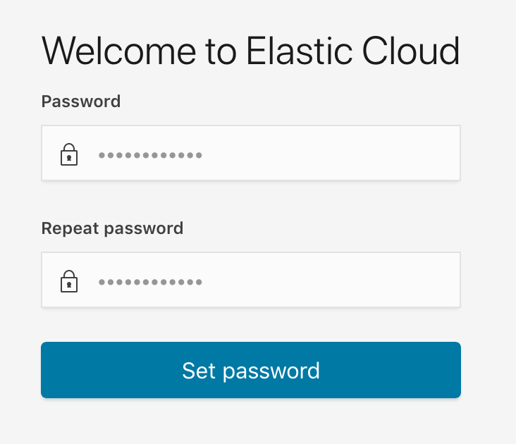

5. You should now be looking at the dashboard. Click “Create deployment”.

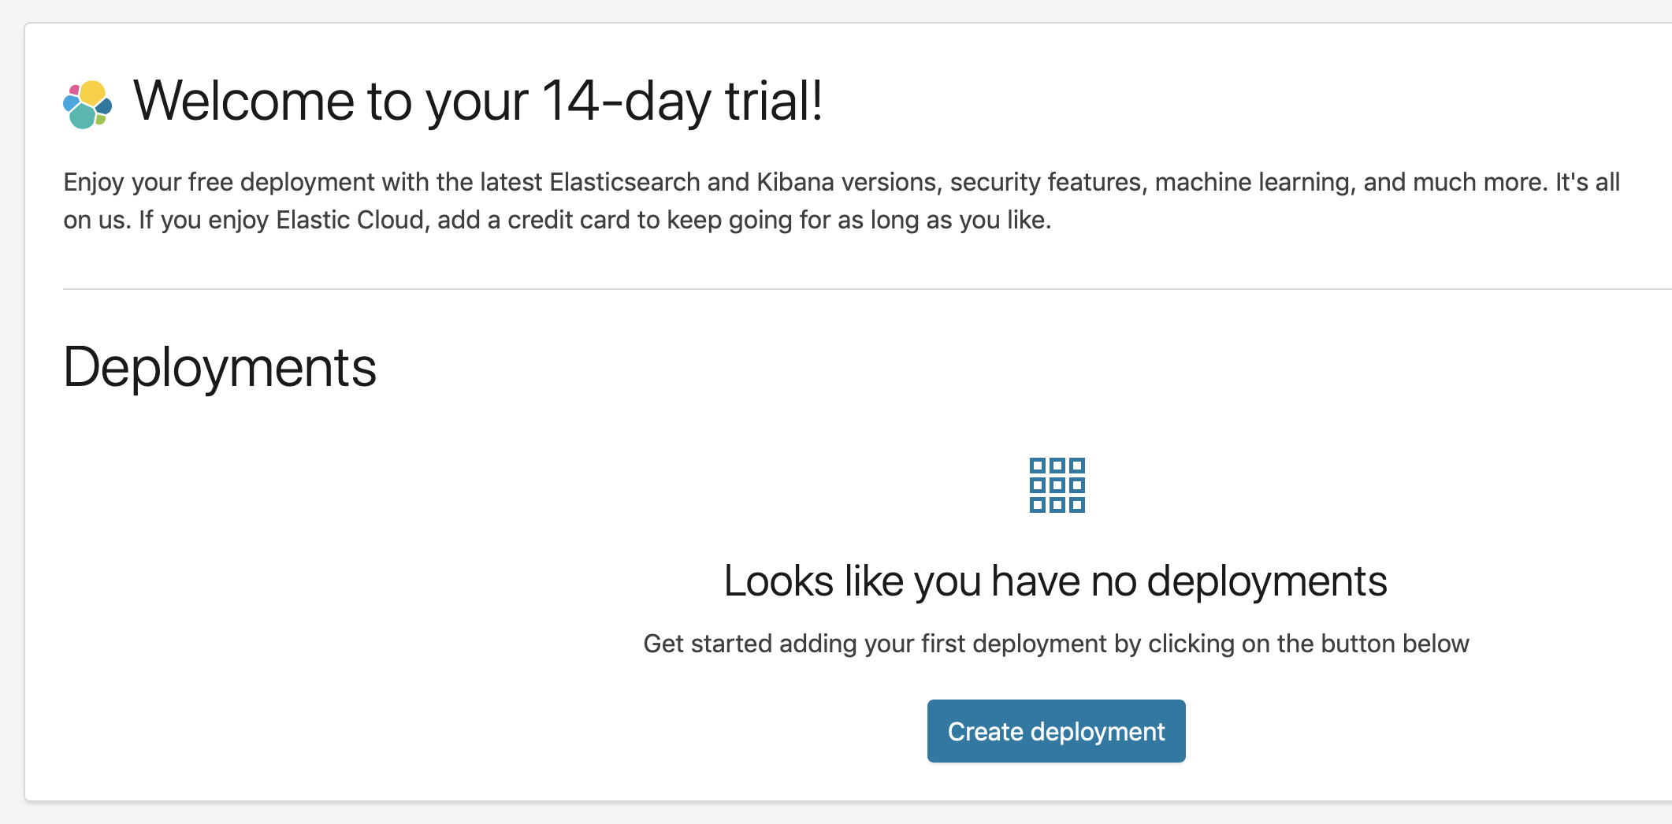

6. Give your deployment a name.

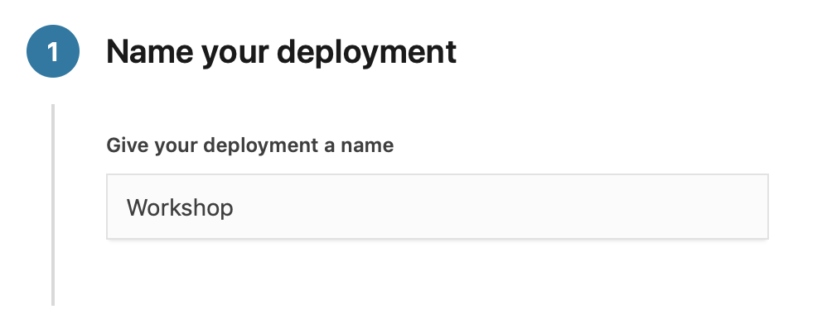

7. Pick the cloud platform of your choice.

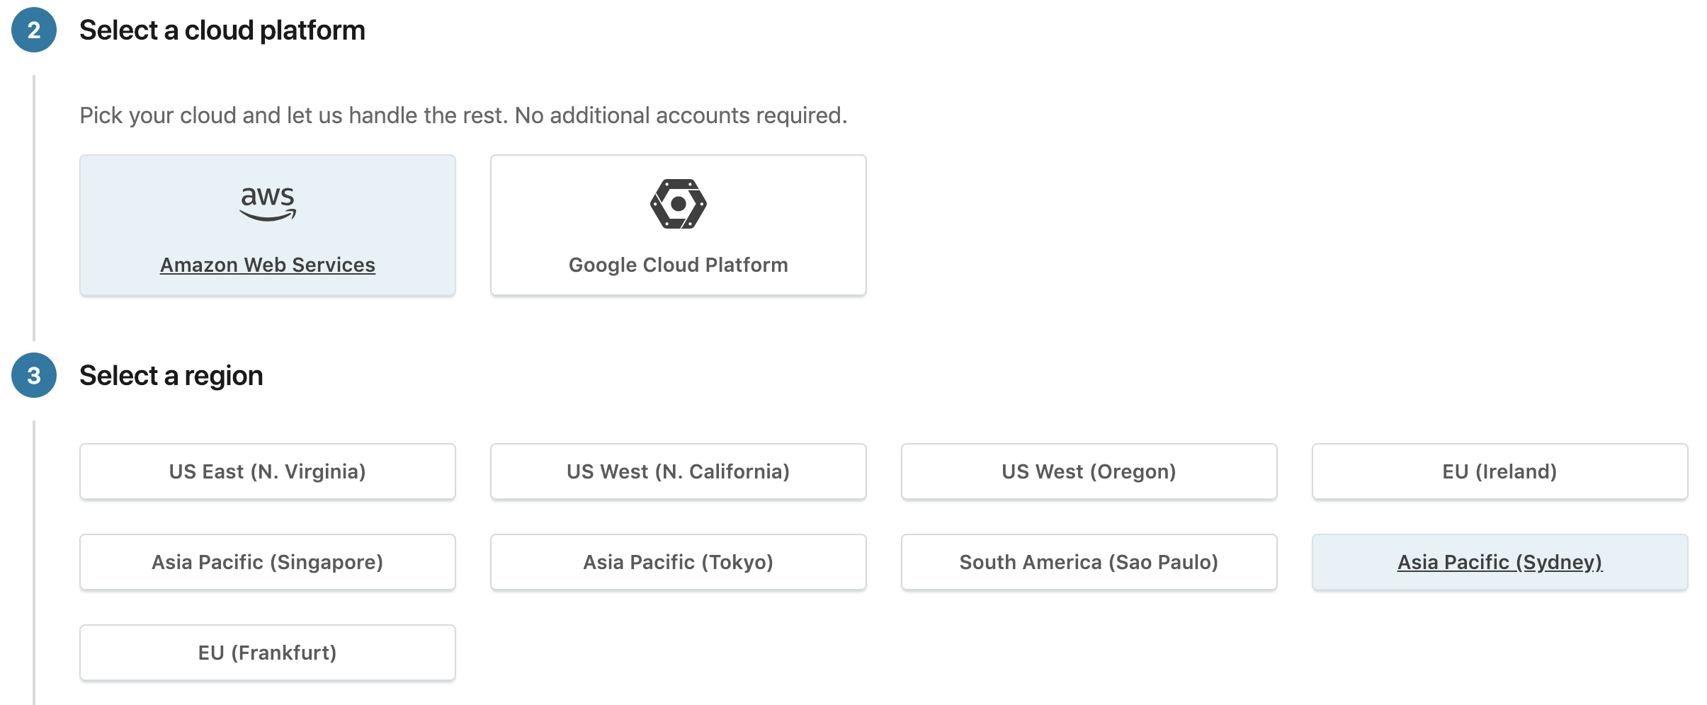

8. Pick the latest version of Elastic.

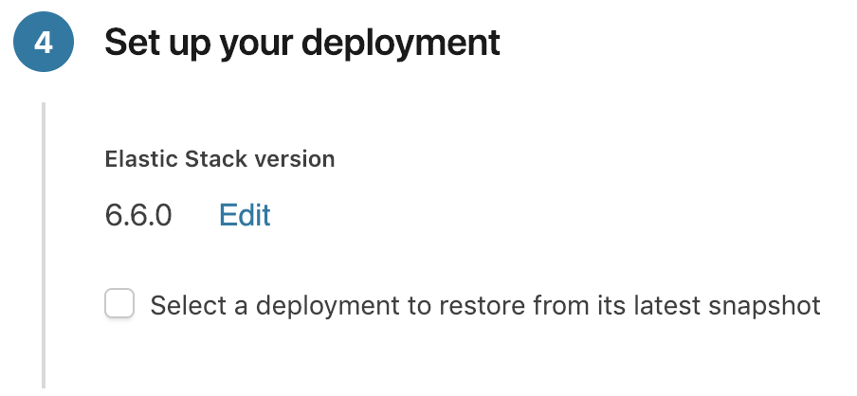

9. Select the I/O optimised deployment template.

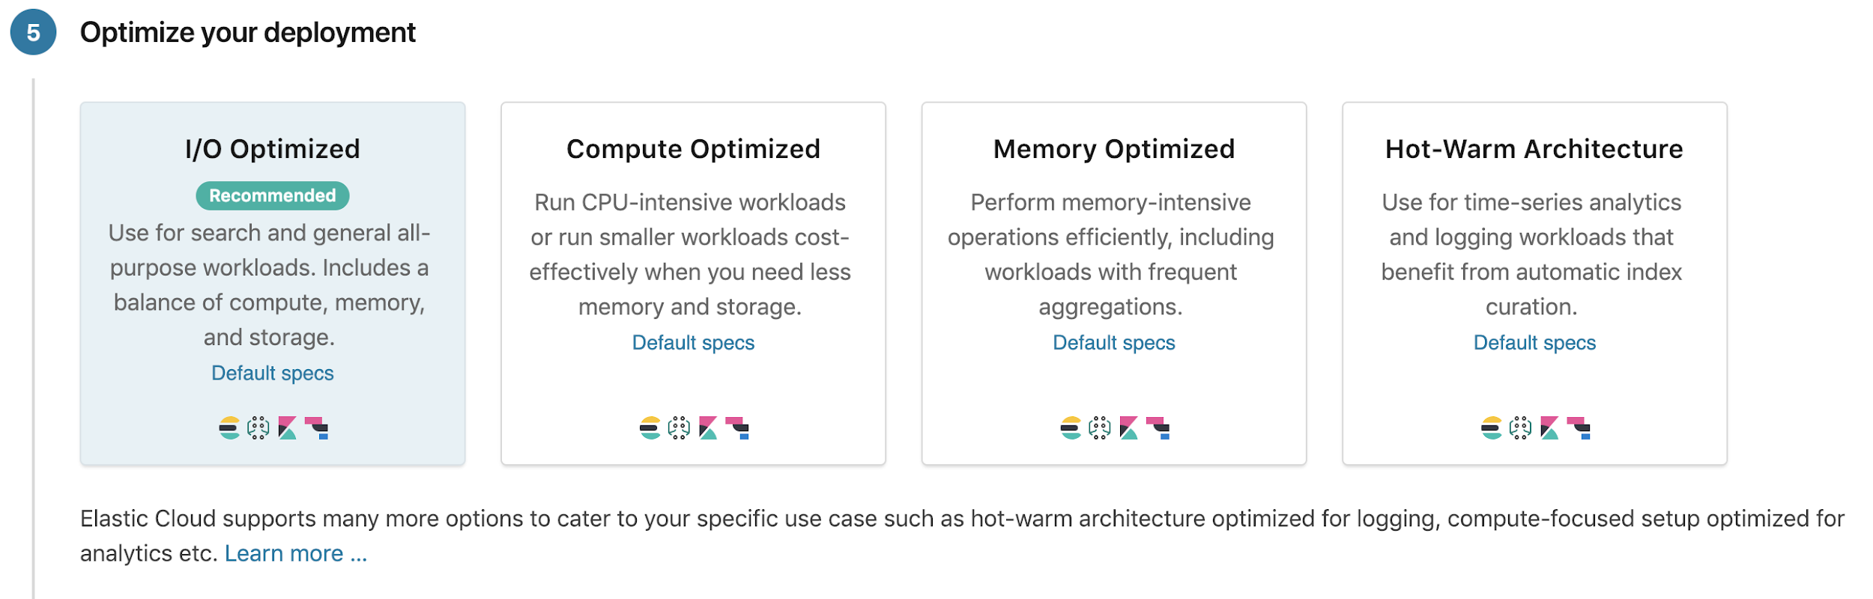

10. Click “Customize deployment”. We want to make a few more changes before creating the deployment.

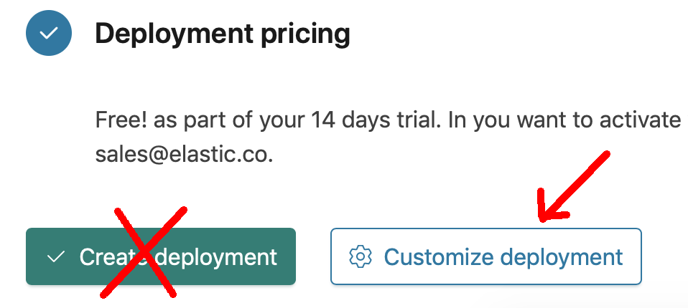

11. Turn on “Machine Learning” by clicking “Enable”.

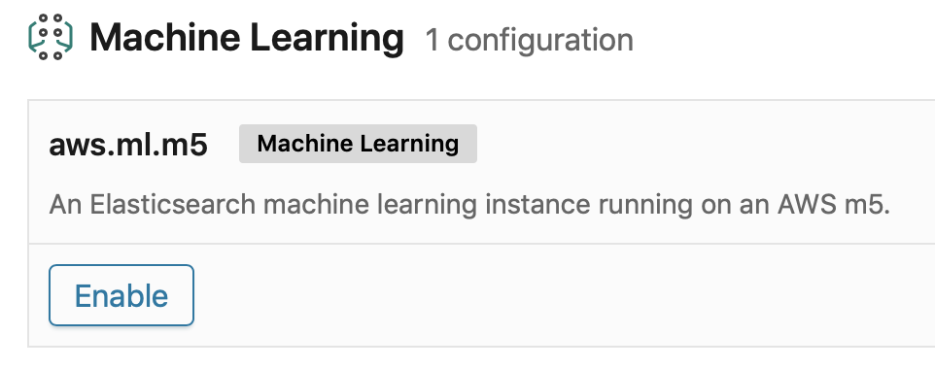

12. Disable APM server by clicking on “Disable”:

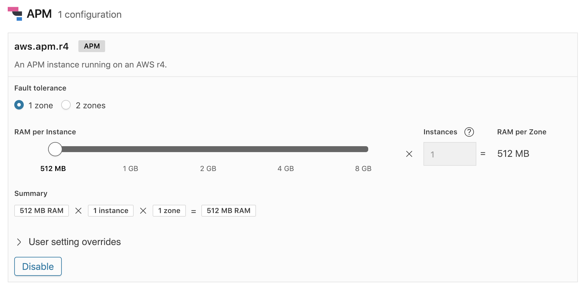

13. Your cluster’s Architecture should look similar to this:

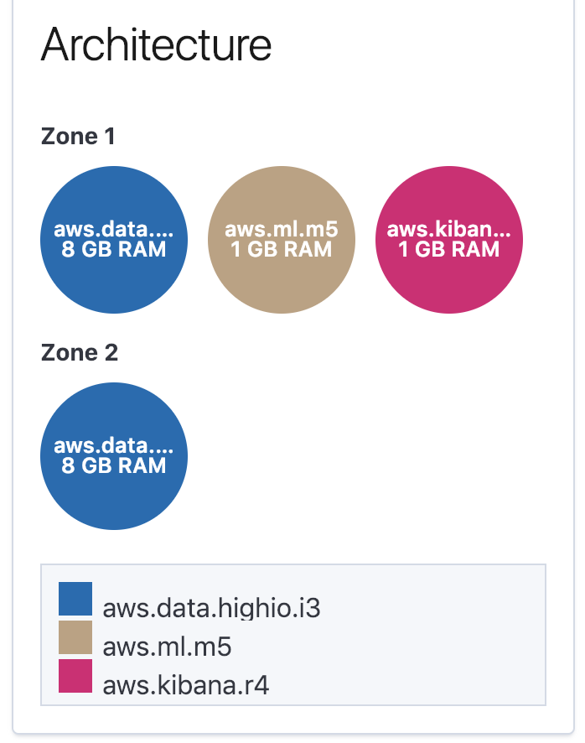

14. Your cluster will begin to spin up. It takes between 3 - 6 minutes to complete.

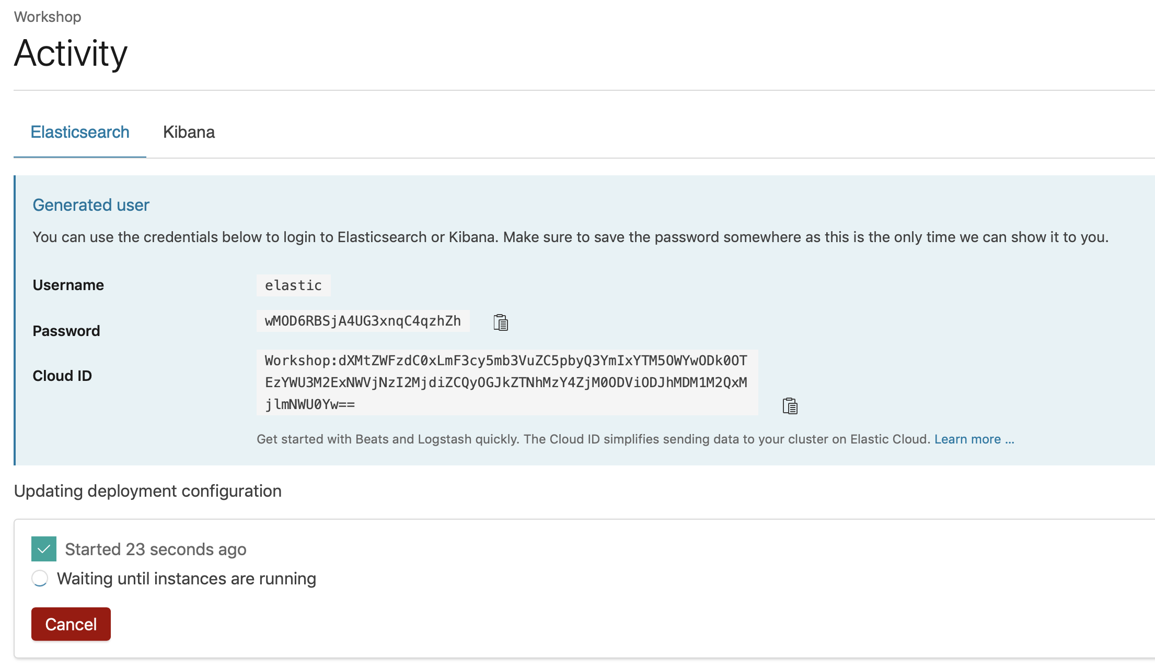

Copy the auto generated Password for future use.

15. When the cluster is ready, select your cluster name in the top left.

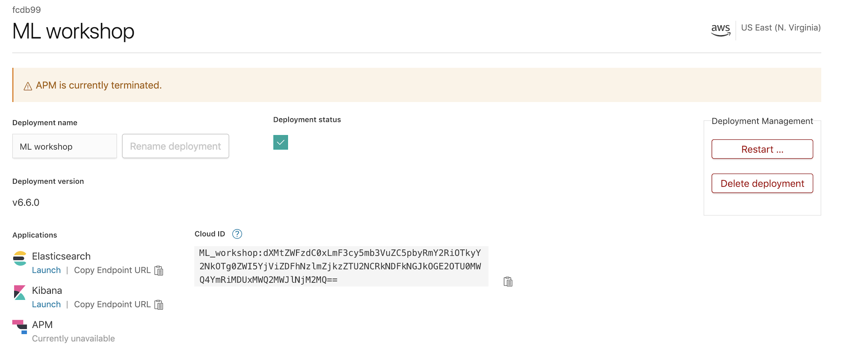

16. Click on Kibana to launch Kibana in a new tab. Login with the username “elastic” and your password (this is the password you copied in Step 18).

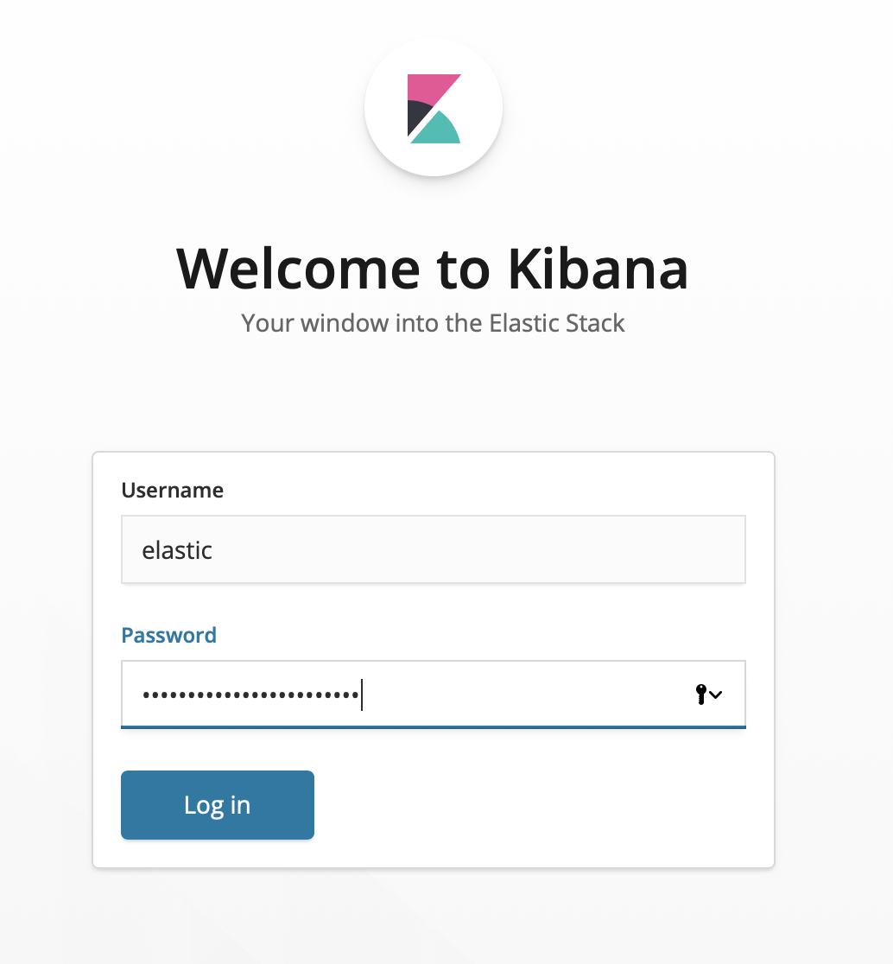

17. You are now in Kibana where you can click “Try our sample data” or wait for the instructor to load your cluster with the data for the workshop.

